Programing Map-Reduce

( Hadoop )

with Eclipse



+

Wei-Yu Chen

NCHC

2008/05/27

see more : http://trac.nchc.org.tw/cloud/

1. Prepare :

System :
  - Ubuntu 7.10
  - Hadoop 0.16

Requirement :
  - Eclipse (3.2.2)

$ apt-get install eclipse

  - java 6

$ apt-get install sun-java6-bin sun-java6-jdk sun-java6-jre sun-java6-plugin

  - suggest to remove the default java compiler “ gcj ”

$ apt-get purge java-gcj-compat

  - Append two codes to /etc/bash.bashrc to setup Java Class path

export JAVA_HOME=/usr/lib/jvm/java-6-sun
export HADOOP_HOME=/home/waue/workspace/hadoop/
export CLASSPATH=.:$JAVA_HOME/lib/dt.jar:$JAVA_HOME/lib/tools.jar

Building UP Path
Name | Path
Hadoop Home | /home/waue/workspace/hadoop/
Java Home | /usr/lib/jvm/java-6-sun

2. Hadoop Setup
  - Generate an SSH key for the user.
$ ssh-keygen -t rsa -P ""
$ cat ~/.ssh/id_rsa.pub >> ~.ssh/authorized_keys
$ ssh localhost
$ exit

  - Installation Hadoop
$ cd /home/waue/workspace
$ sudo tar xzf hadoop-0.16.0.tar.gz
$ sudo mv hadoop-0.16.0 hadoop
$ sudo chown -R waue:waue hadoop
$ cd hadoop

  - Configuration
    - hadoop-env.sh ($HADOOP_HOME/conf/)
    - Change
# The java implementation to use. Required.
# export JAVA_HOME=/usr/lib/j2sdk1.5-sun
to
# The java implementation to use. Required.
export JAVA_HOME=/usr/lib/jvm/java-6-sun
export HADOOP_HOME=/home/waue/workspace/hadoop
export HADOOP_LOG_DIR=$HADOOP_HOME/logs
export HADOOP_SLAVES=$HADOOP_HOME/conf/slaves

    - hadoop-site.xml ($HADOOP_HOME/conf/)
- modify the contents of conf/hadoop-site.xml as below
<configuration>
<property>
<name>fs.default.name</name>
<value>localhost:9000</value>
<description>
</description>
</property>
<property>
<name>mapred.job.tracker</name>
<value>localhost:9001</value>
<description>
</description>
<property>
<name>mapred.map.tasks</name>
<value>1</value>
<description>
define mapred.map tasks to be number of slave hosts
</description>
</property>
<property>
<name>mapred.reduce.tasks</name>
<value>1</value>
<description>
define mapred.reduce tasks to be number of slave hosts
</description>
</property>
<property>
<name>dfs.replication</name>
<value>1</value>
</property>
</configuration>

  - Start Up Hadoop

$ cd $HADOOP_HOME
$ bin/hadoop namenode -format
08/05/23 14:52:16 INFO dfs.NameNode: STARTUP_MSG:
/************************************************************
STARTUP_MSG: Starting NameNode
STARTUP_MSG: host = Dx7200/127.0.1.1
STARTUP_MSG: args = [-format]
STARTUP_MSG: version = 0.16.4
STARTUP_MSG: build = http://svn.apache.org/repos/asf/hadoop/core/branches/branch-0.16 -r 652614; compiled by 'hadoopqa' on Fri May 2 00:18:12 UTC 2008
************************************************************/
08/05/23 14:52:17 INFO fs.FSNamesystem: fsOwner=waue,waue,adm,dialout,cdrom,floppy,audio,dip,video,plugdev,staff,scanner,lpadmin,admin,netdev,powerdev,vboxusers
08/05/23 14:52:17 INFO fs.FSNamesystem: supergroup=supergroup
08/05/23 14:52:17 INFO fs.FSNamesystem: isPermissionEnabled=true
08/05/23 14:52:17 INFO dfs.Storage: Storage directory /tmp/hadoop-waue/dfs/name has been successfully formatted.
08/05/23 14:52:17 INFO dfs.NameNode: SHUTDOWN_MSG:
/************************************************************
SHUTDOWN_MSG: Shutting down NameNode at Dx7200/127.0.1.1
************************************************************/

$ /bin/start-all.sh
starting namenode, logging to /home/waue/workspace/hadoop/logs/hadoop-waue-namenode-Dx7200.out
localhost: starting datanode, logging to /home/waue/workspace/hadoop/logs/hadoop-waue-datanode-Dx7200.out
localhost: starting secondarynamenode, logging to /home/waue/workspace/hadoop/logs/hadoop-waue-secondarynamenode-Dx7200.out
starting jobtracker, logging to /home/waue/workspace/hadoop/logs/hadoop-waue-jobtracker-Dx7200.out
localhost: starting tasktracker, logging to /home/waue/workspace/hadoop/logs/hadoop-waue-tasktracker-Dx7200.out

Then make sure http://localhost:50030/ by your explorer is on going.
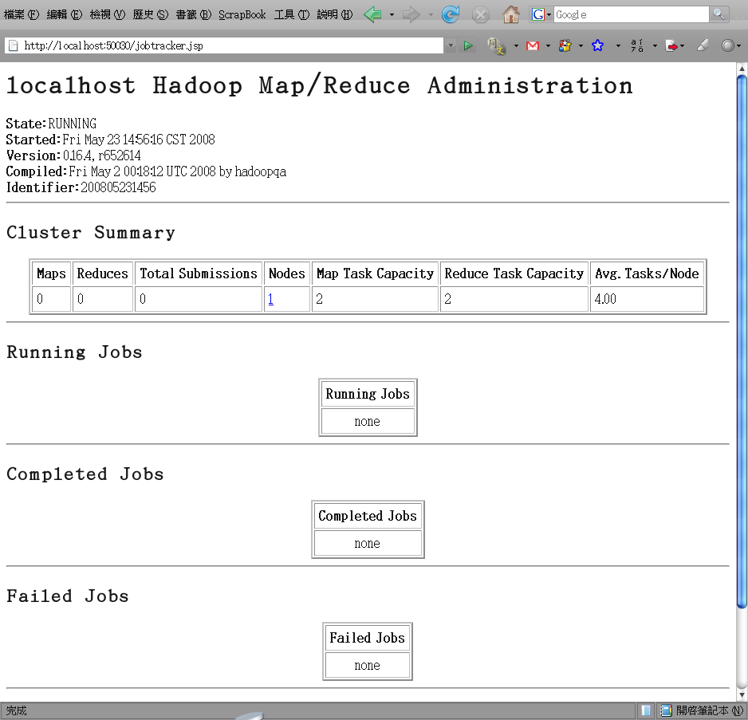

Ps : if your system had error after restart, you could do there for resolving and renewing one.
$ cd $HADOOP_HOME
$ bin/stop-all.sh
$ rm -rf /tmp/*
$ rm -rf logs/*
And repeat to “4. start up Hadoop”

3. Eclipse Setup

3.1 install IBM mapReduce tool
1. Download the IBM MapReduce Tools zip file and extract to /tmp/.
2. Make sure Eclipse is closed and ...
$ cd /tmp/
$ unzip mapreduce_tools.zip
$ mv plugins/com.ibm.hipods.mapreduce* /usr/lib/eclipse/plugins/

3. Restart Eclipse
ps : check IBM MapReduce Tools plugin installing well

Eclipse
File > New > Project
- see MapReduce category

3.2 Subclipse

3.2.1 Install
- Open Eclipse and click

Eclipse
Help -> Software Updates -> Find and Install... -> search for new features ... -> new remote site ->
- name : subclipse 1.2.x
- site : URL: http://subclipse.tigris.org/update_1.2.x

-> new remote site ->
- name : subclipse 1.0.x
- site : http://subclipse.tigris.org/update_1.0.x
-> Finish

ps 1 : You can reference the subclipse installing guild ( http://subclipse.tigris.org/install.html )
ps 2 : Why should we install both subclipse 1.0.x and subclipse 1.2.x ? Because subclipse 1.2.x is suitable for eclipse 3.2 but with some “software dependency” error. Installing subclipse 1.0.x can resolve the problem.

3.2.2 Configure

Eclipse
Window > Preferences > Team > SVN > SVN interface
- choose SVNKit

ps 1 : When operating the procedure above, you may happen “Javahl interface is not available” problem. You can do it to resolve.

$ sudo apt-get install libsvn-javahl libsvn-dev
$ sudo ln -s /usr/lib/jni/libsvnjavahl-1.so /usr/lib/jvm/java-6-sun/jre/lib/i386/client/libsvnjavahl-1.so

3.3 Eclipse configure

Eclipse
Window > Preferences > java> compiler
- set compiler compliance level to 5.0

4. Run on Eclipse

4.1 install map-reduce sample

Eclipse
Window > Open Perspective > Other > SVN Repository Exploring.

Right clicking on left panel

New > Repository Location
- umd-hadoop-dist: https://subversion.umiacs.umd.edu/umd-hadoop/dist
- umd-hadoop-core: https://subversion.umiacs.umd.edu/umd-hadoop/core

For each repository, when expanding the tree, "branches", "tags", and "trunk" will be appearance.

Right click on trunk > Checkout...

And then wait until the checkout process is complete

ps : Subclipse exhaust resource very much, you may happen to “out of memory error”. We suggest to execute eclipse with some parameters as that : “eclipse -vmargs -Xmx 512m"

Eclipse
Window > Open Perspective > Other > Java

you should have two new projects: umd-hadoop-core[trunk] and umd-hadoop-dist [trunk]

Eclipse
Project > Clean... > ok

ps : You might get 9 warning in umd-hadoop-core[trunk] without any error. If you have error, please check Window > Preferences > java> compiler > compiler compliance level is 5.0

4.2. Connect to Hadoop File System

Enable the MapReduce servers window

Eclipse
Window > Show View > Other... > MapReduce Tools > MapReduce Servers

At the bottom of your window, you should have a "MapReduce Servers" tab. If not, see second bullet above. Switch to that tab.

At the top right edge of the tab, you should see a little blue elephant icons.

Eclipse
Click blue elephant to add a new MapReduce server location.
- Server name : any_you_want
- Hostname : localhost
- Installation directory: /home/waue/workspace/nutch/
- Username : waue

If any password prompt, please input the password which you login to local

It should show up under a little elephant icon in the Project Explorer (on the left side of Eclipse).

ps : Pleast make sure your Hadoop is working on local system. If not, please refer “session 2 Hadoop Setup” for debuging, or you can not pass through.

$ cd /home/waue/workspace/hadoop/
$ wget http://www.gutenberg.org/etext/132/132.txt
$ bin/hadoop dfs -mkdir input
$ bin/hadoop dfs -ls
Found 1 items
/user/waue/input <dir> 2008-05-23 15:15 rwxr-xr-x waue supergroup
$ bin/hadoop dfs -put 132.txt input

4.3 Modify sample code

Eclipse
umd-hadoop-core[trunk] > src > edu.umd.cloud9.demo > click twice DemoWordCount.java

Modify the value :

public static void main(String[] args) throws IOException {
String filename = "/user/waue/test/132.txt";
String outputPath = "sample-counts";

Eclipse
umd-hadoop-core[trunk] > src > edu.umd.cloud9.demo > right click DemoWordCount.java > run as ... > run on Hadoop > choose an existing server from the list below > finish

A “console” tag will show beside “MapReduce Server” tag.

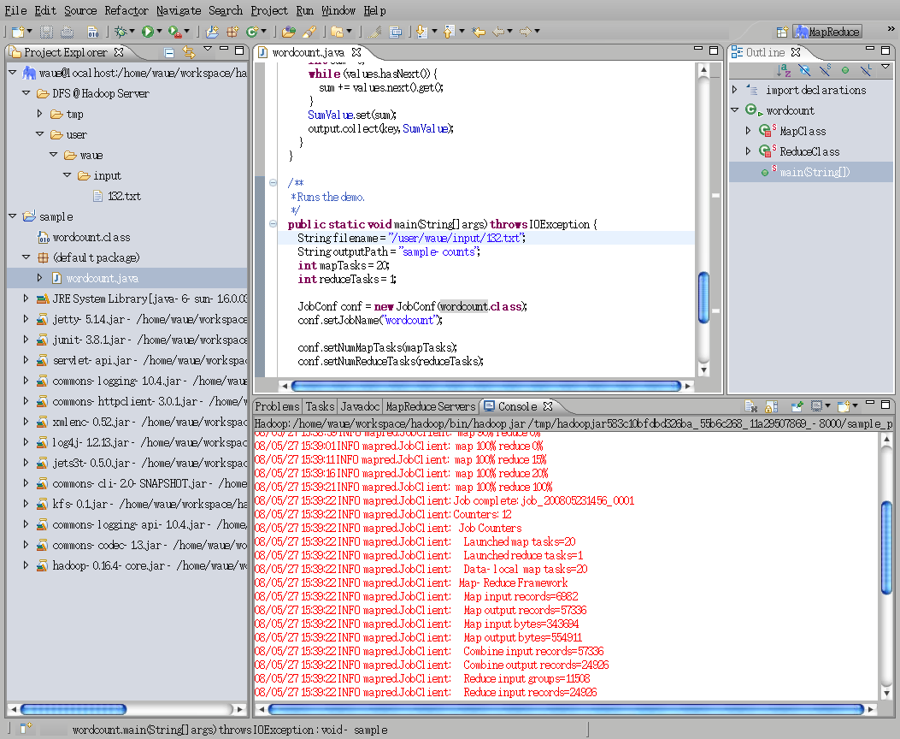

While Map Reduce is running, you can visit http://localhost:50030/ to view that Hadoop is dispatching jobs by Map Reduce.

After finish, you can go to http://localhost:50060/ to see the result.

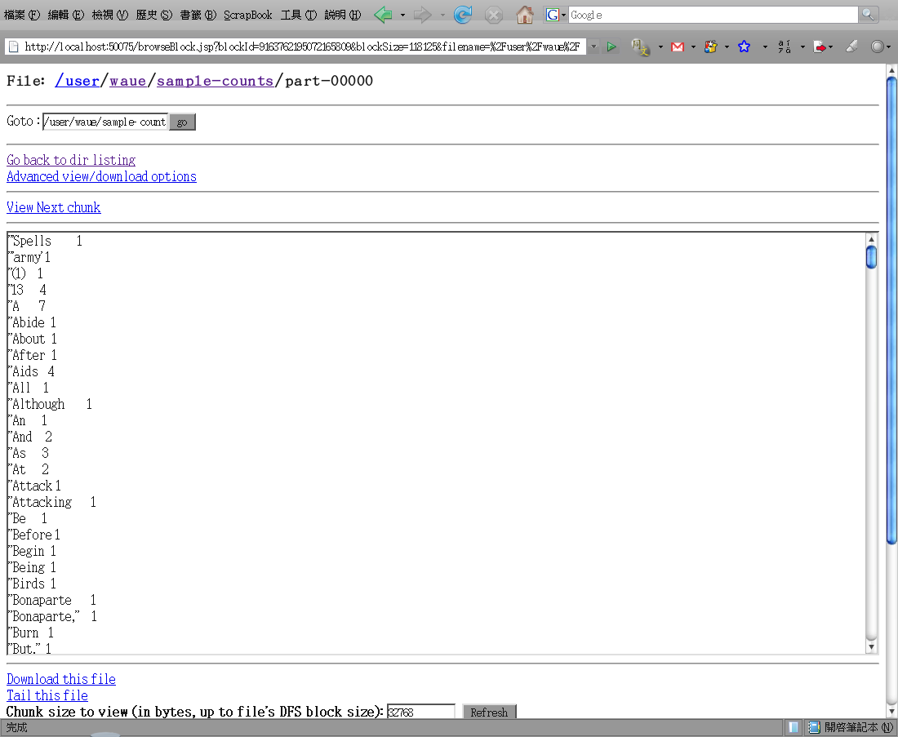

5. Reference

- NCHC Cloud Technique Develop Group http://trac.nchc.org.tw/cloud/
- IBM Map-Reduce http://www.alphaworks.ibm.com/tech/mapreducetools
- Cloud9 http://www.umiacs.umd.edu/~jimmylin/cloud9/umd-hadoop-dist/cloud9-docs/howto/start.html
- Runing Hadoop http://www.michael-noll.com/wiki/Running_Hadoop_On_Ubuntu_Linux_%28Single-Node_Cluster%29

Related Files :
    - IBM map reduce tool : http://www.alphaworks.ibm.com/tech/mapreducetools
    - word sample 1 : The Art of War by 6th cent. B.C. Sunzi http://www.gutenberg.org/etext/132
    - word sample 2 : The Adventures of Sherlock Holmes by Sir Arthur Conan Doyle http://www.gutenberg.org/etext/1661

